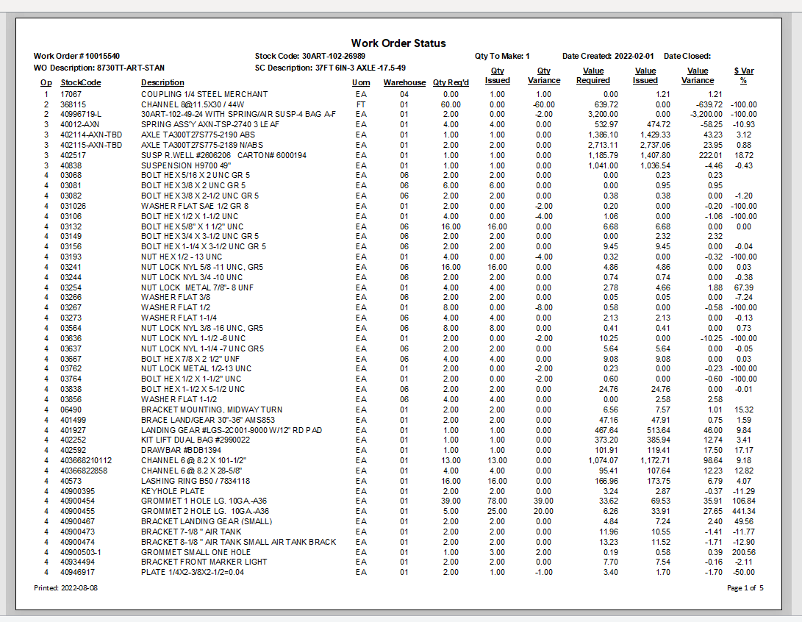
Difference between the amount that was predicted for the unit and what was used.
Qty manufacturing have used to the workorder.
Qty then Eng./BOM believe the workorder required.
Default warehouse.

Part number.
Operation the part is required for.
Stocking unit of measure.
Item description in short.

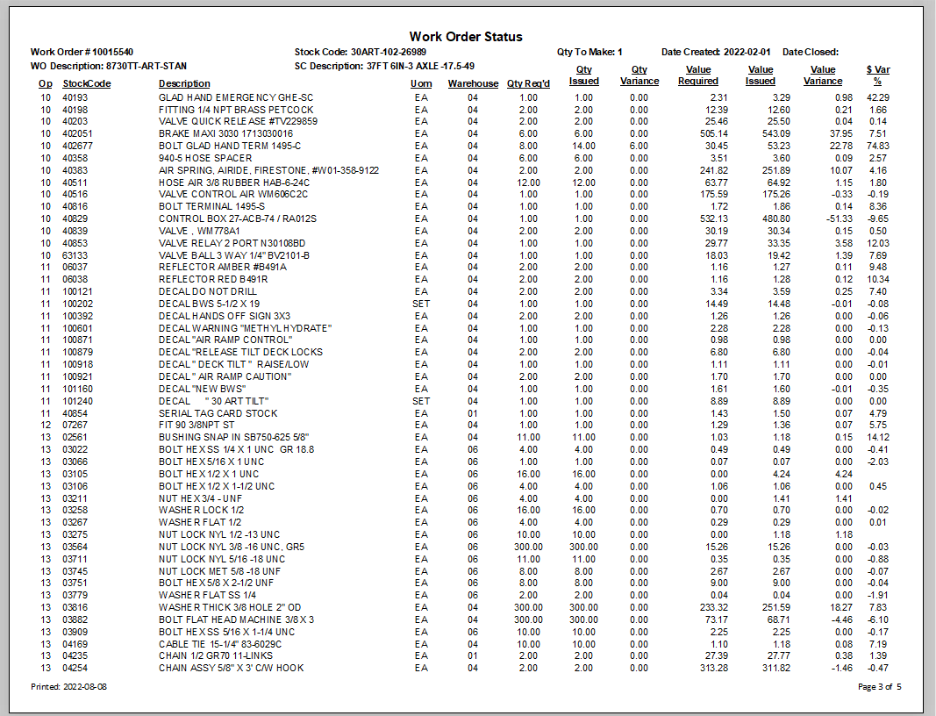
Dollar value required (when part was added on).
Dollar value issued (when part was added on).

Difference between money $$ required and issued.
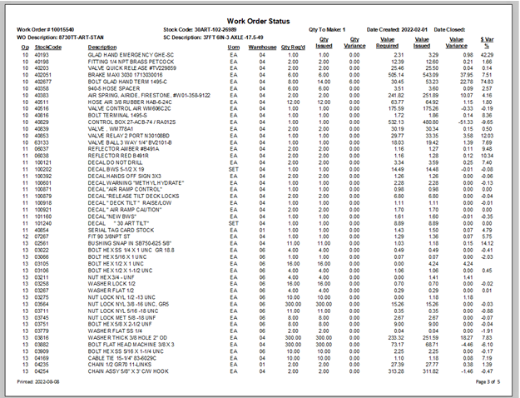
This shows the cost difference
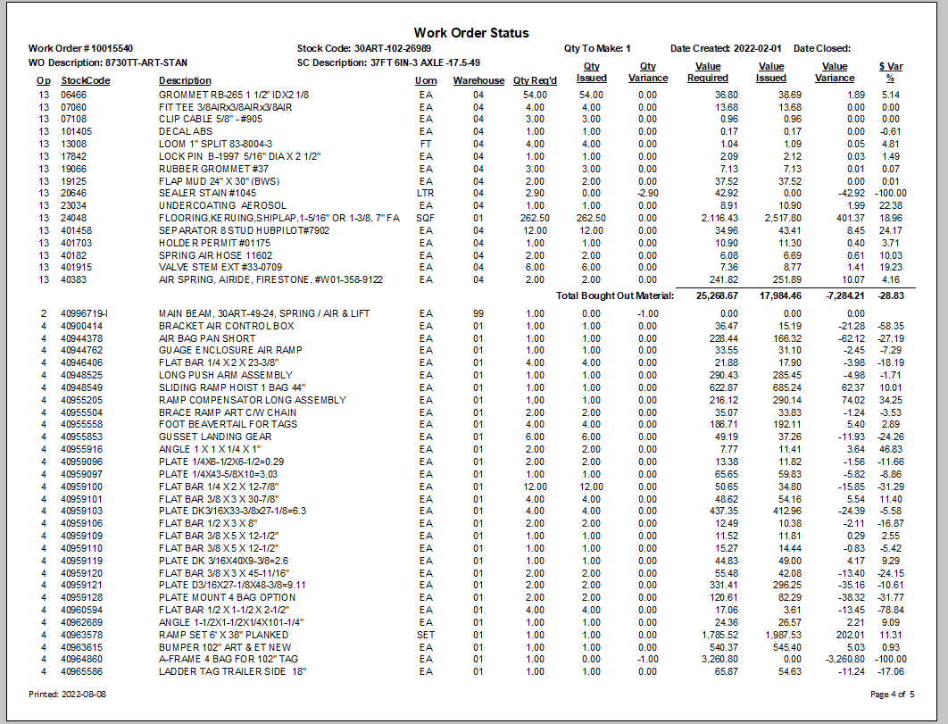
Report is divided into bought out, made in, subcontract and labor cost $$.
This is the bought-out subtotal.
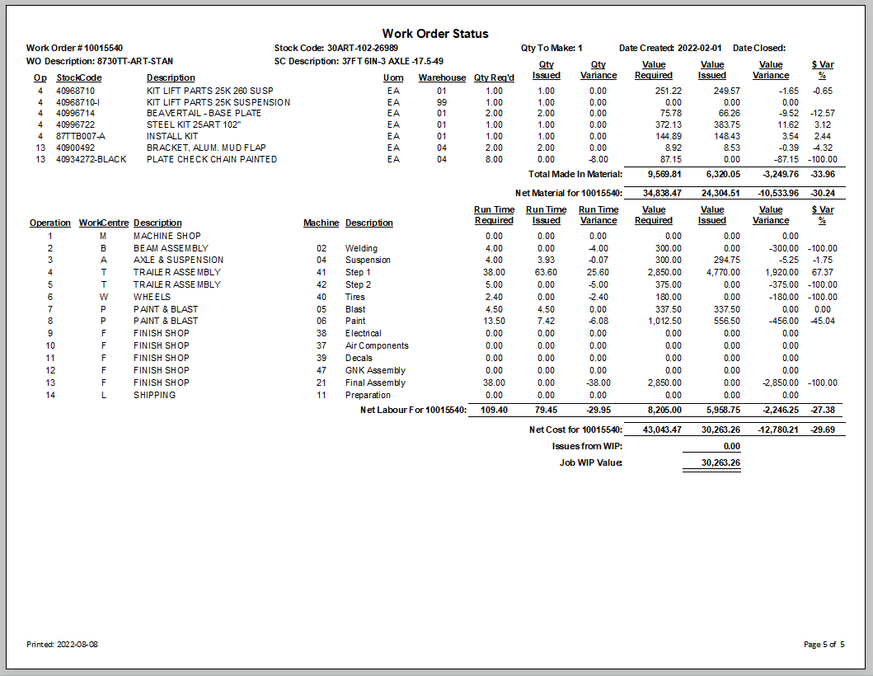
Description of the stock code being made.
This is the stock code being made by this work order.
Work order number.

Date the work order was closed. If blank I is still open and in process.
Date the work order was first made.
Material, sub total bought out, made in, sub contact.
Made in subtotal.

